BJT LED and Relay Driver HW (35 + 3 EC Points)
(jas, BJT LED and Relay Driver HW.docx, 11/4/2025)

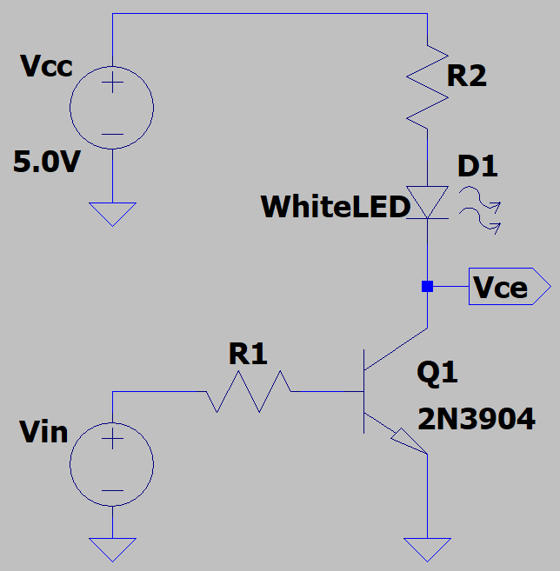
- An npn LED driver circuit is illustrated below in Figure 1. For this circuit the White LED is off for V_{s} = 0 V with the LED on for V_{in} = 3.3 V. You are to determine standard ±5% resistance values for R1 and R2 needed to turn on the White LED with V_{in} = 3.3 V from microcontroller digital output. For your R2 calculations, design for an LED on current of 20 mA at an LED forward voltage of 3.2 V. For your R2 calculation, assume V_{CE} = 0 V for Q1 when V_{in} = 3.3 V, which is a commonly used approximation for saturation of a bipolar junction transistor. For your R1 calculations, assume the usual 0.7 V V_{BE} approximation for bipolar junction transistors, along with a β_{min} = 10 for the transistor Q1 in saturation. Choose the closest standard resistance value for R1 that results in a base current of (20 mA)/ β_{min}. (Note: Standard resistor values only include discrete values, with standard ±5% resistor values including the following discrete multipliers: (1.0, 1.1, 1.2, 1.3, 1.5, 1.6, 1.8, 2.0, 2.2, 2.4, 2.7, 3.0, 3.3, 3.6, 3.9, 4.3, 4.7, 5.1, 5.6, 6.2, 6.8, 7.5, 8.2, 9.1). For example, given a calculated resistance of 2.1 kΩ, the closest ±5% values would be 2.0 kΩ or 2.2 kΩ.) Include your calculations below, along with the actual resistor values chosen based on the available discrete ±5% resistor values. (6 points total.)

Figure 1: npn LED Driver Circuit.
$$R_{1}=\frac{V_{R1}}{I_{R1}}=\frac{V_{in}-V_{BE}}{I_{B}}=\frac{3.3V-0.7V}{2mA}=1.3 kΩ$$
R1_{_Actual} = $1.3 kΩ$ (3 points.)

$$R_{2}=\frac{V_{R2}}{I_{R2}}=\frac{V_{CC}-V_{CE}-V_{D}}{I_{D}}=\frac{5.0V-3.2V}{20mA}=90Ω≈91Ω$$
R2_{_Actual} = $91Ω$ (3 points.)

- Next connect up your npn LED driver circuit in LTspice. Please consult the LTspice Help if questions arise. The specific model for a 2N3904 is chosen by first placing an npn transistor, then hovering the cursor over the device until the hand symbol appears, then right clicking to enable a pane that allows you to Pick New Transistor, with a 2N3904 available near the top of the pick list. The transistor type can also be changed simply by editing the value from NPN to 2N3904 on the schematic. For the LED, first place a generic LED from the main LTspice library, referred to as LED. Next include an external White LED model by first changing the LED type from D to WhiteLED. There is now an older and newer version of LTspice, with some nomenclature differences between the two versions. The newer version uses the .t icon on the top toolbar, or in the edit pull-down menu, to open a Spice Directive window, whereas the older version used the .op option in the Edit pull-down menu. A Spice Directive window is where simulation commands and model parameters not in the LTspice parts library are entered for inclusion on an LTspice schematic. Open a Spice Directive window and paste the following model information for the White LED:

.model WhiteLED D (IS=93.1P RS=42M N=6.45 BV=5 IBV=30U
+ CJO=2.97P VJ=.75 M=.333 TT=4.32U)x

Next on the Edit pull-down menu in the upper left-hand corner, choose Configure SPICE Analysis and choose DC op pnt, which calculates the DC operating point of your circuit. Then set the V_{in} voltage source to 3.3 V and add the net label V_{ce} to the collector of the 2N3904. In the Edit pull-down menu, add your name to your schematic as follows: Edit Aa Text. When completed with your schematic, replace the schematic shown in Figure 2 below with your version, including your chosen resistor values for R1 and R2 along with your name. (6 points.)
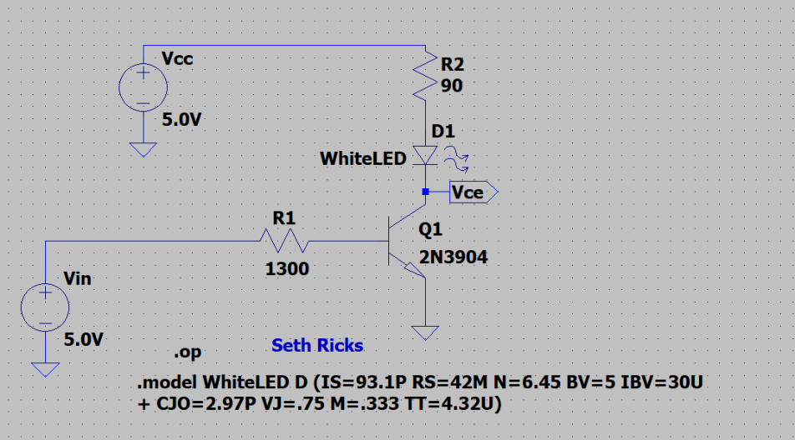
Figure 2: LTspice npn LED Driver Circuit.
After running the simulation, an operating point netlist will appear, indicating all DC voltages and currents. Record the V_{CE}, I_{B} and I_{C} values in Table 1 along with the calculated transistor current gain β = I_{C}/I_{B}., which is much less in saturation than in the active region. (Note: The transistor collector current should be greater than 18 mA to visibly turn on the White LED and less than 22 mA.) (4 points.)

Table 1: npn LED Driver Circuit Values for the LED On State.
V_{in} | V_{CE} | I_{B} | I_{C} | β
5.0 V | 0.0327507 | 0.00321895 | 0.019652 | 6.105
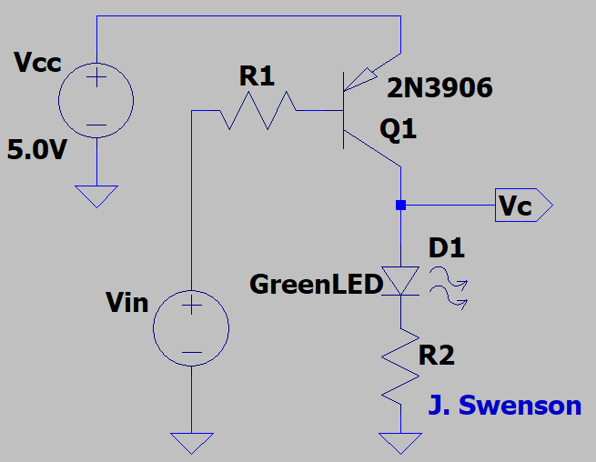
- A pnp LED driver circuit is illustrated below in Figure 3. For this circuit, the Green LED is off for V_{s} = 5.0 V with the LED on for V_{in} = 0.0 V. You are to determine standard ±5% resistance values for R1 and R2 needed to turn on the Green LED with V_{in} = 0.0 V from microcontroller digital output. For your R2 calculations, design for an LED on current of 20 mA at an LED forward voltage of 2.7 V. For your R2 calculation, assume V_{EC} = 0 V for Q1 when V_{in} = 0.0 V, which is a commonly used approximation for saturation of a bipolar junction transistor. For your R1 calculations, assume the usual 0.7 V V_{BE} approximation for bipolar junction transistors, along with a β_{min} = 10 for the transistor Q1 in saturation. (Note: Standard resistor values only include discrete values, with standard ±5% resistor values including the following discrete multipliers: (1.0, 1.1, 1.2, 1.3, 1.5, 1.6, 1.8, 2.0, 2.2, 2.4, 2.7, 3.0, 3.3, 3.6, 3.9, 4.3, 4.7, 5.1, 5.6, 6.2, 6.8, 7.5, 8.2, 9.1). Include your calculations below, along with the actual resistor values chosen based on the available discrete ±5% resistor values. (6 points total.)
Figure 3: pnp LED Driver Circuit.

$$I_{B}=\frac{I_{C}}{β_{min}}=\frac{20mA}{10}=2mA$$
$$R_{1}=\frac{V_{R1}}{I_{R1}}=\frac{V_{CC}-V_{EB}-V_{in}}{I_{B}}=\frac{5V-0.7V-0V}{2mA}=2150Ω≈2.2kΩ$$
R1_{_Actual} = $2.2kΩ$(3 points.)

$$R_{2}=\frac{V_{R2}}{I_{R2}}=\frac{V_{CC}-V_{D1}}{I_{D1}}=\frac{5V-2.7V}{20mA}=1.15Ω≈120Ω$$
R2_{_Actual} = $120Ω$

- Next connect up your pnp LED driver circuit in LTspice. Please consult the LTspice Help if questions arise. The specific model for a 2N3906 is chosen by first placing a pnp transistor, then hovering the cursor over the device until the hand symbol appears, then right clicking to enable a pane that allows you to Pick New Transistor, with a 2N3906 available near the top of the pick list. The transistor type can also be changed simply by editing the value from PNP to 2N3906 on the schematic. For the LED, first place a generic LED from the main LTspice library, referred to as LED. Next include an external White LED model by first changing the LED type from D to GreenLED. There is now an older and newer version of LTspice, with some nomenclature differences between the two versions. The newer version uses the .t icon on the top toolbar, or in the edit pull-down menu, to open a Spice Directive window, whereas the older version used the .op option in the Edit pull-down menu. A Spice Directive window is where simulation commands and model parameters not in the LTspice parts library are entered for inclusion on an LTspice schematic. Open a Spice Directive window and paste the following model information for the Green LED:

.model LedGreen D (IS=93.2p RS=42m N=5.43 EG=2.4 BV=4 IBV=10u
+ CJO=2.97p VJ=0.75 M=0.333 TT=4.32u Iave=40m Vpk=4 type=LED)

Next on the Edit pull-down menu in the upper left-hand corner, choose Configure SPICE Analysis and choose DC op pnt, which calculates the DC operating point of your circuit. Then set the V_{in} voltage source to 5.0 V and add the net label V_{ec} to the collector of the 2N3904. After running the simulation, an operating point netlist will appear, indicating all DC voltages and currents with V_{EC} = 5.0 V - V_{C}. Negative I_{B} and I_{C} values indicate conventional current flowing out of the respective terminals. Record the V_{EC}, I_{B} and I_{C} values in Table 2 along with the calculated transistor current gain β = I_{C}/I_{B}., which is much less in saturation than in the active region. (Note: The transistor collector current magnitude should be greater than 18 mA to visibly turn on the Green LED and less than 22 mA.) (4 points.)

Table 2: npn LED Driver Circuit Values for the LED On State.
V_{in} | V_{EC} | I_{B} | I_{C} | β
0.0 V | 0.04077 | -0.00191684 | -0.0189315 | 9.876

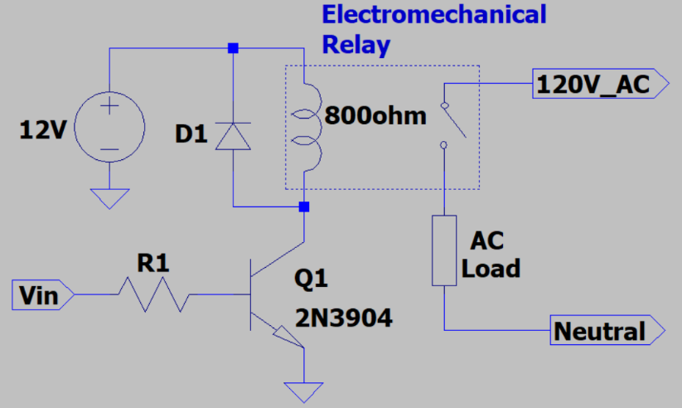
- An npn relay driver circuit is illustrated below in Figure 5. For this circuit the relay is off for V_{in} = 0 V and on (closed) for V_{in} = 3.3 V. Calculate the saturation current I_{C_sat} of Q1 along with the resistance value of R1 needed to turn on the relay with V_{in} = 3.3 V from a microcontroller digital output. For your I_{C_sat} calculation, assume V_{CE} = 0 V for Q1 when V_{in} = 3.3 V, which is a commonly used approximation for saturation of a bipolar junction transistor. For your R1 calculations, assume the usual 0.7 V V_{BE} approximation for bipolar junction transistors, along with a β_{min} = 10 for the transistor Q1 in saturation. (Note: Standard resistor values only include discrete values, with standard ±5% resistor values including the following discrete multipliers: (1.0, 1.1, 1.2, 1.3, 1.5, 1.6, 1.8, 2.0, 2.2, 2.4, 2.7, 3.0, 3.3, 3.6, 3.9, 4.3, 4.7, 5.1, 5.6, 6.2, 6.8, 7.5, 8.2, 9.1). Include your calculations below, along with the actual resistor values chosen based on the available discrete ±5% resistor values. (5 points total.)
Figure 4: npn Relay Driver Circuit.
$$I_{C_sat}=\frac{12V}{800Ω}=15mA$$
I_{C_sat} = $15mA$ (2 points.)

$$R_{1}=\frac{V_{R1}}{I_{R1}}=\frac{V_{in}-V_{BE}}{\frac{I_{C}}{β_{min }}}=\frac{3.3-0.7}{1.5mA}=1733Ω≈1.8kΩ$$
R1_{_Actual} = $1.8kΩ$ (3 points.)

- Next connect up your npn relay driver circuit for a DC operating point simulation (DC op pnt) in LTspice to verify a relay coil current close to your I_{C_sat} calculated in the previous problem for V_{in} = 3.3 V. For this simulation, model the relay coil as an 800 Ω resistor. Also, it is not necessary to include diode D1 in your LTspice simulation as it does not impact the DC performance. Then set the V_{in} voltage source to 3.3 V and add the net label V_{ce} to the collector of the 2N3904. After running the simulation, an operating point netlist will appear, indicating all DC voltages and currents. Record the V_{CE}, I_{B} and I_{C} values in Table 3 along with the calculated transistor current gain β = I_{C}/I_{B}., which is much less in saturation than in the active region. (Note: The transistor collector current should be greater than 13 mA and less than 17 mA.) (4 points.)

Table 3: npn Relay Driver Circuit Values for the LED On State.
V_{in} | V_{CE} | I_{B} | I_{C} | β
3.3 V | 0.0404997 | 0.00140802 | 0.0149494 | 10.617

Extra Credit Problem: Using your own words and at least 3 sentences, explain the purpose of diode D1 in Figure 3. (3 points.)

This is a flyback diode. It protects against reverse current that may occur from the relay. If it wasn’t there, it could damage components such as the transistor or microcontroller.

